#include <iostream>

1

using namespace std;

int main()

{

int x;

int y;

cout << "Enter x: ";

cin >> x;

cout << "Enter y: ";

cin >> y;

if (x <= 3 && x >= -1 && y <= 4 && y >= -2)

{

cout << "Point belongs";

}

else

{

cout << "Point does not belong";

}

}

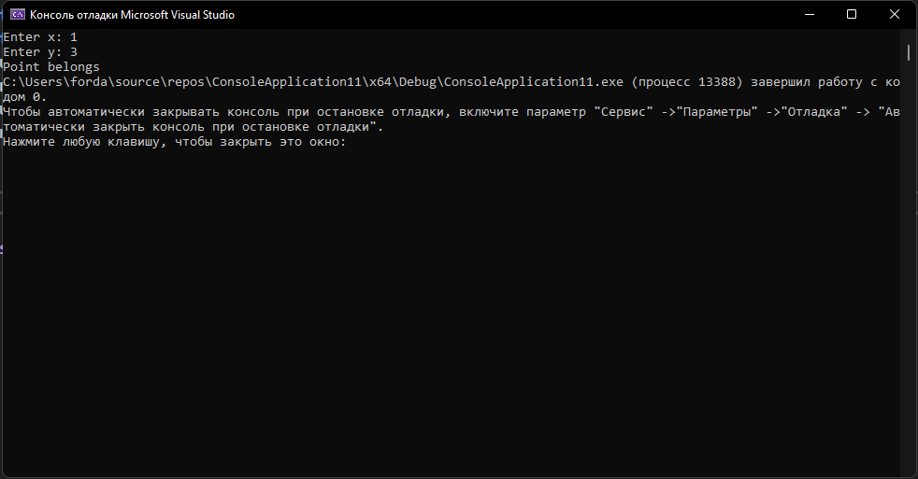

#include <iostream>

2

using namespace std;

int main()

{

int x;

int y;

cout << "Enter x: ";

cin >> x;

cout << "Enter y: ";

cin >> y;

int a = (x - 0) * (y - (-3)) - (x - 2) * (y - 2);

int b = (x - 2) * (y - (-3)) - (x - (-2)) * (y - (-3));

int c = (x - (-2)) * (y - 2) - (x - 0) * (y - (-3));

if (((a >= 0 && b >= 0 && c >= 0) || (a <= 0 && b <= 0 && c <= 0)))

{

cout << "Point belongs to the triangle";

}

else

{

cout << "Point does not belongs to the triangle";

}

}

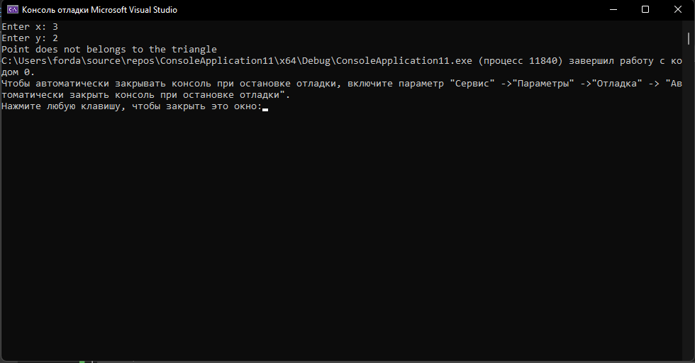

#include <iostream>

3

#include <math.h>

using namespace std;

int main()

{

int x;

int y;

cout << "Enter x: ";

cin >> x;

cout << "Enter y: ";

cin >> y;

if (x >= -3 && x <= 5 && y >= -1 && y <= 4)

{

cout << "Point belongs";

}

else

{

cout << "Point does not belongs";

}

}

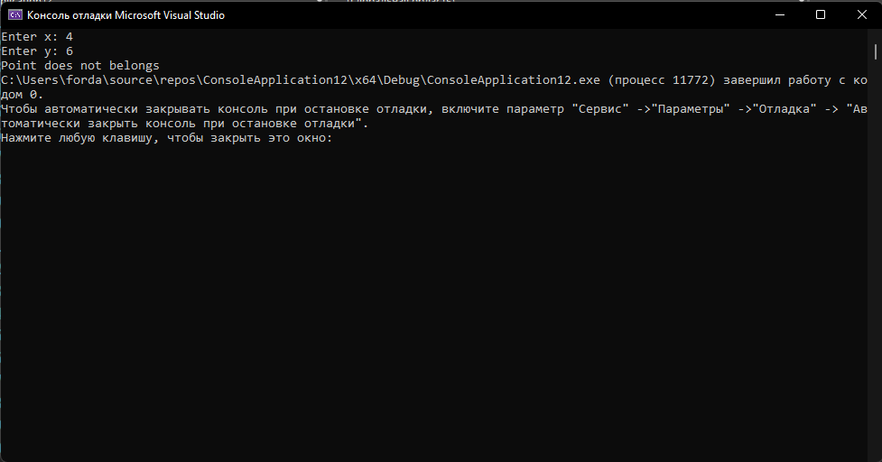

#include <iostream>

4

#include <math.h>

using namespace std;

int main()

{

double a;

double b;

double c;

cout << "Enter a: ";

cin >> a;

cout << "Enter b: ";

cin >> b;

cout << "Enter c: ";

cin >> c;

if (a == 0)

{

cout << "No roots";

return 0;

}

double d = pow(b, 2) - (4 * a * c);

cout << "Discriminant: " << d << endl;

if (d > 0)

{

double x1 = (-b - sqrt(d)) / 2 * a;

double x2 = (-b + sqrt(d)) / 2 * a;

cout << "First root: ";

cout << x1 << endl;

cout << "Second root: ";

cout << x2;

}

else if (d == 0)

{

double x1 = -b / (2 * a);

cout << "First root: ";

cout << x1;

}

else if(d < 0)

{

return 0;

}

}

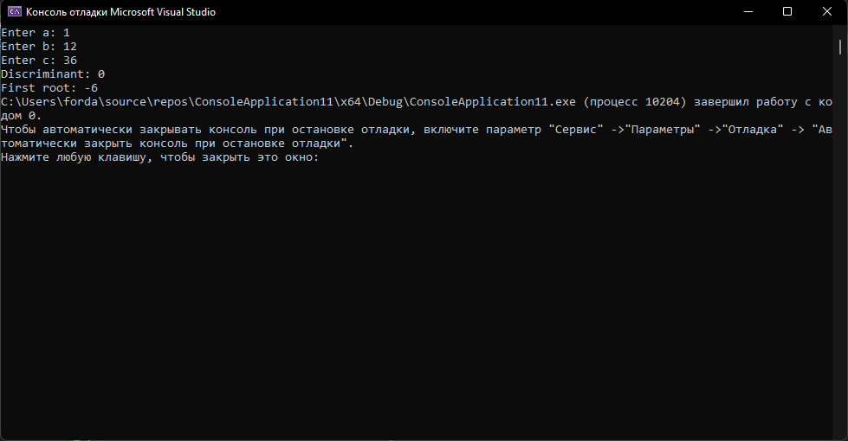

#include <iostream>

5

#include <math.h>

using namespace std;

int main()

{

cout << "Enter date: ";

int user;

cin >> user;

int day = user % 7;

switch (day)

{

case 1:

cout << ("Monday");

break;

case 2:

cout << ("Tuesday");

break;

case 3:

cout << ("Wednesday");

break;

case 4:

cout << ("Thursday");

break;

case 5:

cout << ("Friday");

break;

case 6:

cout << ("Saturday");

break;

case 0:

cout << ("Sunday");

break;

}

}

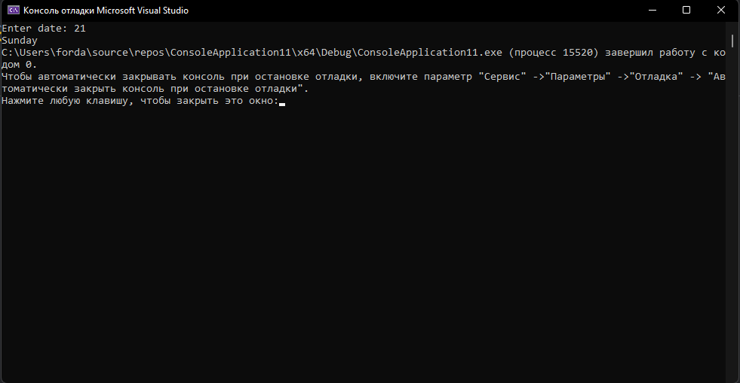

#include <iostream>

6

#include <math.h>

using namespace std;

int main()

{

double a;

double y;

cout << "Enter a = ";

cin >> a;

if (a < -3)

{

y = 3;

}

else if (a < 2)

{

y = 4;

}

else

{

y = 1;

}

cout << "Result y = " << y;

}

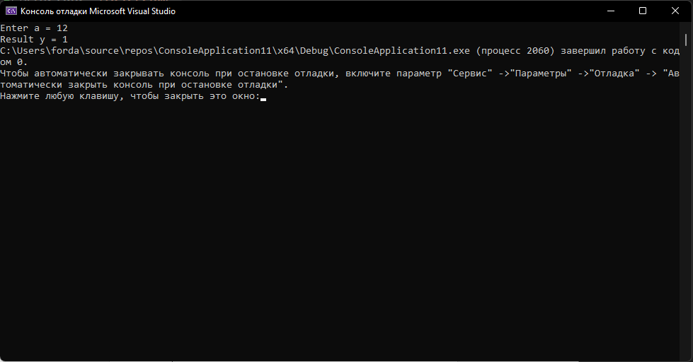

#include <iostream>

7

#include <math.h>

using namespace std;

int main()

{

double a = 0;

double y = 0;

cout << "Enter a = ";

cin >> a;

if (a < 1)

y = pow(0.5, a);

else

y = (3.0 / 4.0) * (a - 1) + 2;

cout << "Resalt y = " << y;

}

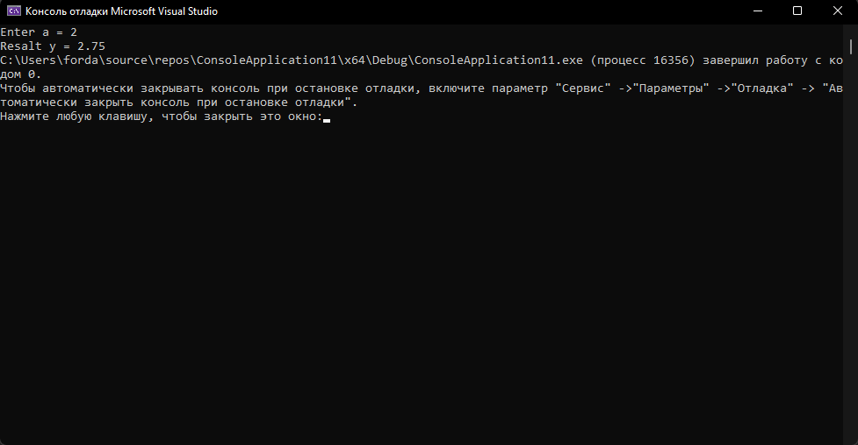

#include <iostream>

8

#include <math.h>

using namespace std;

int main()

{

int a;

int b;

int k;

int m;

cout << "Enter a = ";

cin >> a;

cout << "Enter b = ";

cin >> b;

cout << "Enter k = ";

cin >> k;

cout << "Enter m = ";

cin >> m;

if (a == k)

{

if (b == m)

{

cout << "Lines match";

}

else

{

cout << "Lines do not match";

}

}

else

{

double x = (m - b) / (a - k);

double y = a * x + b;

cout << "Lines intersect at a point: " << '(' << x << ';' << y << ')';

}

}

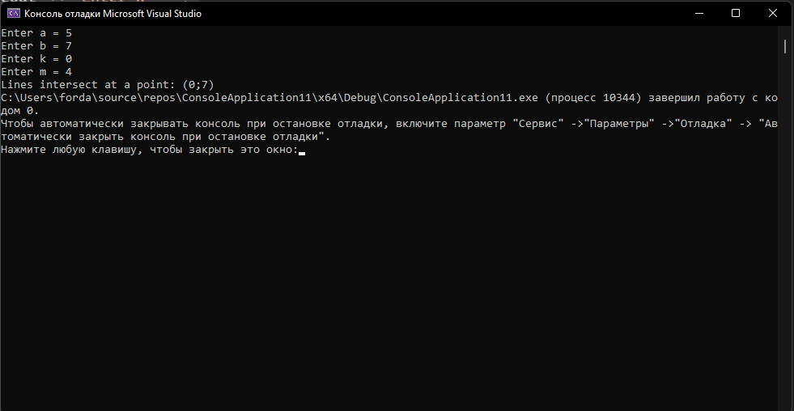

#include <iostream>

9

#include <math.h>

using namespace std;

int main()

{

int r;

int x;

int y;

int dotx;

int doty;

cout << "Enter R (radius) = ";

cin >> r;

cout << "Enter center X = ";

cin >> x;

cout << "Enter center Y = ";

cin >> y;

cout << "Enter dotX = ";

cin >> dotx;

cout << "Enter dotY = ";

cin >> doty;

double geo = pow((dotx - x), 2) + pow((doty - y), 2) - pow(r, 2);

if (geo < 0)

{

cout << "Point located inside";

}

else if (geo > 0)

{

cout << "Point located outside";

}

else

{

cout << "Point lies on the circle";

}

}

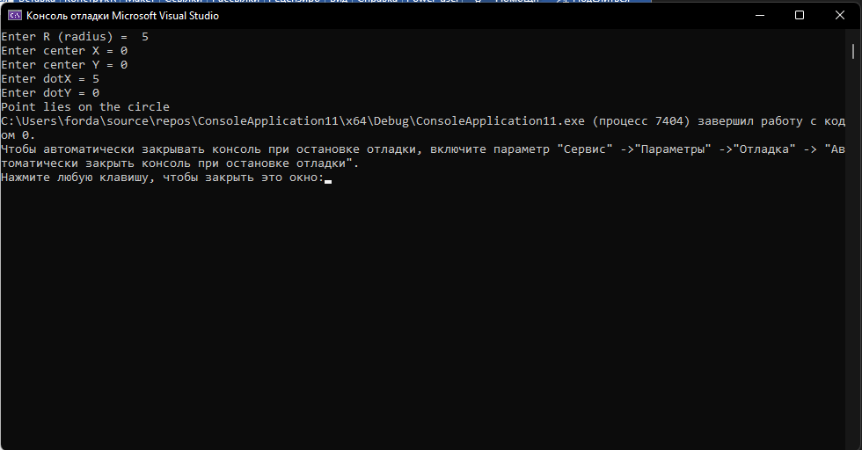

#include <iostream>

10

#include <math.h>

using namespace std;

int main()

{

int r;

int x;

int y;

int dotx;

int doty;

cout << "Enter R (radius) = ";

cin >> r;

cout << "Enter center X = ";

cin >> x;

cout << "Enter center Y = ";

cin >> y;

double ura = (pow(r, 2)) - (pow(y, 2));

if (ura >= 0)

{

double dotx = -sqrt(r * r - y * y) + x;

double doty = sqrt(r * r - y * y) + x;

cout << "The point of intersection with the abscissa in points " << dotx << " and " << doty;

}

else

{

cout << ("The circle does not intersect with the abscissa axis");

}

}

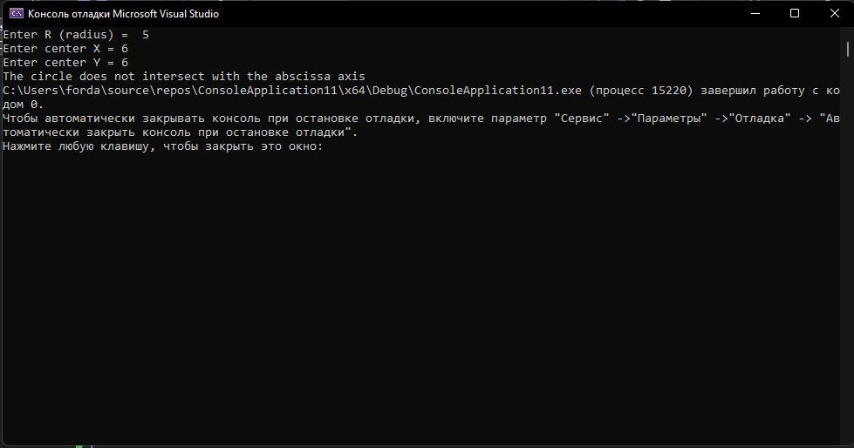

#include <iostream>

11

#include <math.h>

using namespace std;

int main()

{

double x;

double y;

double a;

double b;

cout << ("Enter a = ");

cin >> a;

cout << ("Enter b = ");

cin >> b;

if (a == 0)

{

cout << ("The graph of the function does not intersect with the abscissa axis");

}

else

{

x = -b / a;

y = a * x + b;

cout << ("The graph crosses the abscissa at points ") << x << " and " << y;

}

}

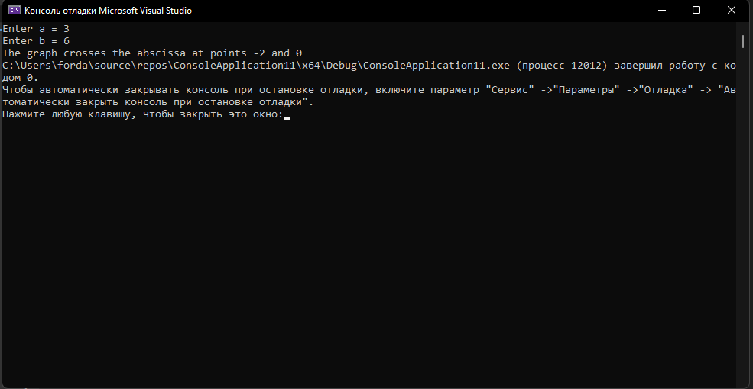

#include <iostream>

12

#include <math.h>

using namespace std;

int main()

{

double a;

double b;

double h;

double y;

cout << ("Enter a = ");

cin >> a;

cout << ("Enter b = ");

cin >> b;

cout << ("Enter h = ");

cin >> h;

for (double x = a; x < b; x += h)

{

y = 5.4 * pow(x, 3) - 2.8 * pow(x, 2) - x + 1.6;

cout << "X:" << x << " Y:" << y << endl;

}

}

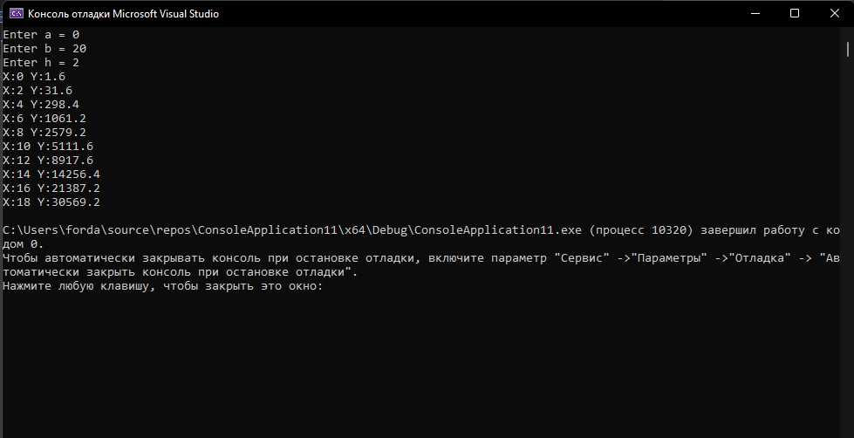

#include <iostream>

13

#include <math.h>

using namespace std;

int main()

{

double a = -2;

double b = 2;

double h = 0.25;

double y;

for (double x = a; x < b; x += h)

{

y = -1.3 * pow(x, 2) - exp(x) / 4;

cout << "X:" << x << " Y:" << y << endl;

}

}

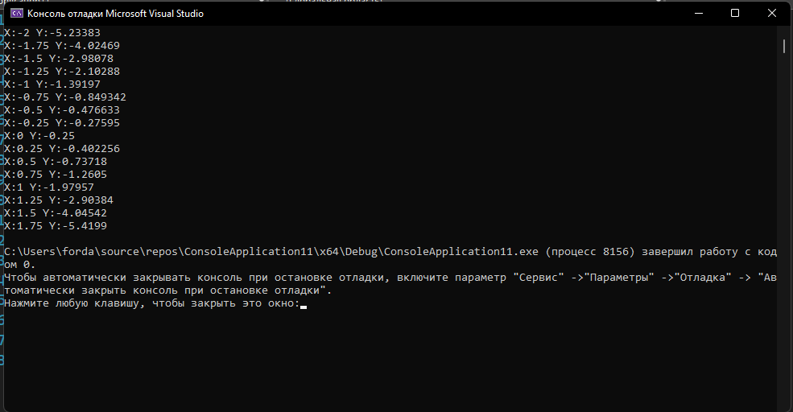

#include <iostream>

14

#include <math.h>

using namespace std;

static int Factorial(int numb)

{

int res = 1;

for (int i = numb; i > 1; i--)

res *= i;

return res;

}

int main()

{

int n;

cout << "Enter n = ";

cin >> n;

double sum = 0;

for (int i = 1; i <= n; i++)

{

sum += i;

}

double p = Factorial(n) / sum;

cout << ("Result p = ") << p;

}

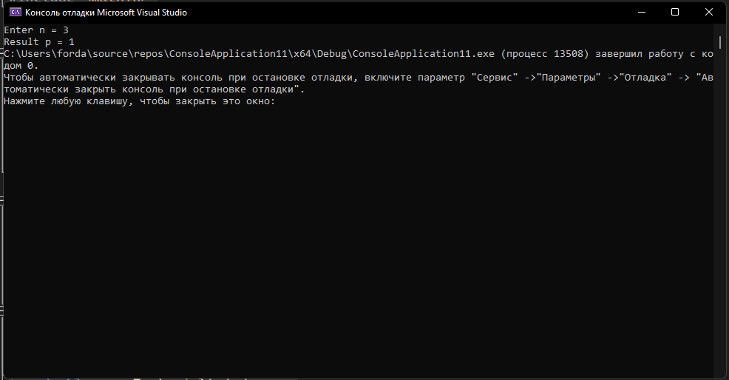

#include <iostream>

15

#include <math.h>

using namespace std;

int main()

{

int num = 0;

for (int i = 10; i < 100; i++)

{

if (i % 2 == 0 && i % 10 != 0)

{

num += 1;

}

}

cout << "The number of natural two-digit even numbers not divisible by 10: " << num;

}

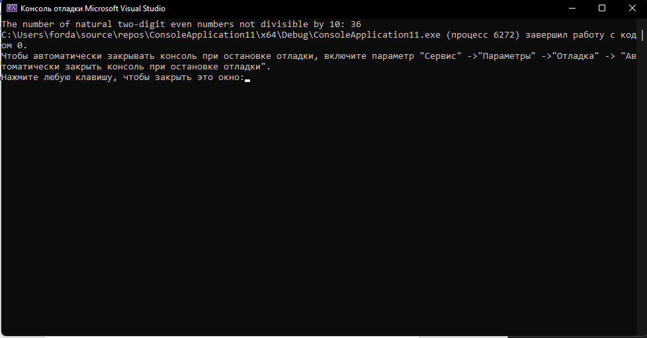

#include <iostream>

16

#include <math.h>

using namespace std;

static int Factorial(int numb)

{

int res = 1;

for (int i = numb; i > 1; i--)

res *= i;

return res;

}

int main()

{

int n = 5;

double sum = 0;

for (int i = 1; i <= 5; i++)

{

sum += pow(3, i);

}

double p = sum / Factorial(n);

cout << ("Result p = ") << p;

}

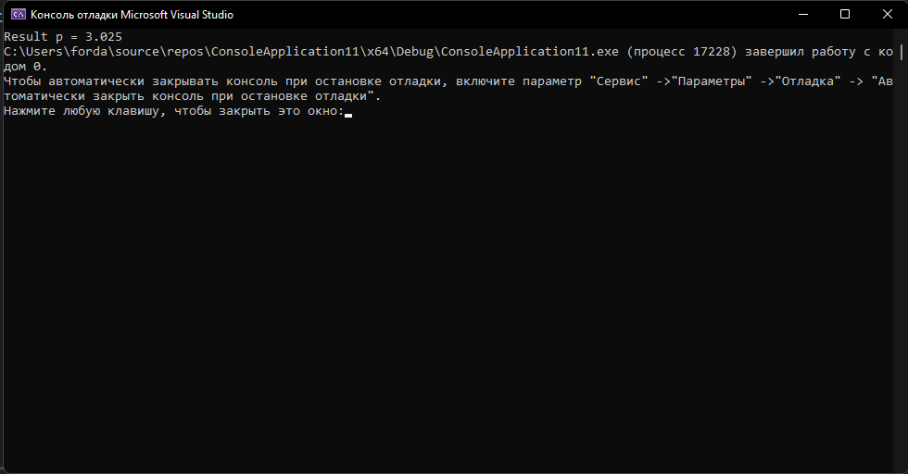

#include <iostream>

17

#include <math.h>

using namespace std;

int main()

{

cout << "Enter n = ";

int n;

cin >> n;

int umn = 1;

for (int i = 1; i < n; i++)

{

if (i % 3 == 0)

{

umn *= i;

}

}

cout << "Product of numbers: " << umn;

}

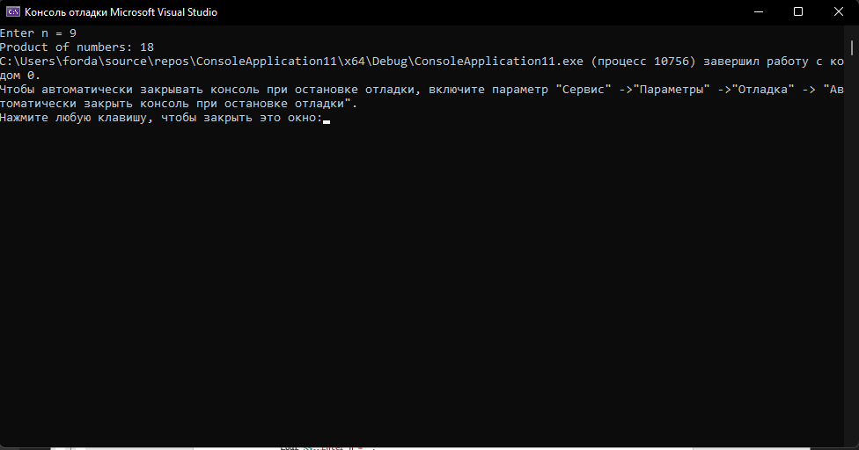

#include <iostream>

18

#include <math.h>

using namespace std;

int main()

{

int num = 1;

int sum = 0;

while (num != 0)

{

cout << ("Enter the sequence number: ");

cin >> num;

if (num > 0)

{

sum += num;

}

else

{

continue;

}

}

cout << "Sum of positive numbers in a sequence: " << sum;

}

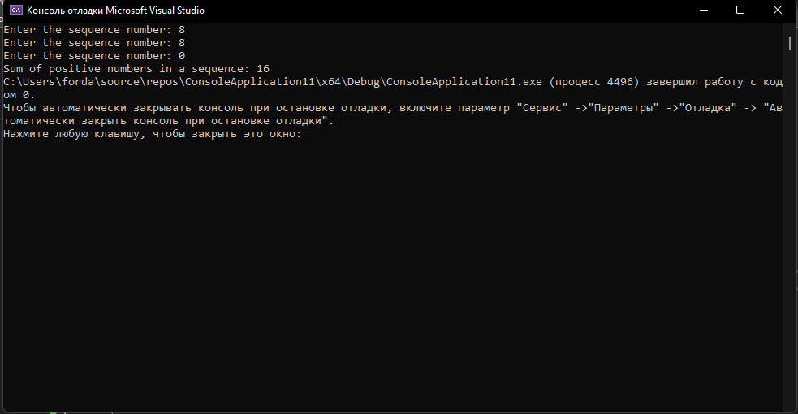

#include <iostream>

19

#include <math.h>

using namespace std;

int main()

{

int num = 1;

int sum = 0;

while (num != 0)

{

cout << ("Enter the next number in the sequence: ");

cin >> num;

if (num > sum)

{

sum = num;

}

}

cout << ("Largest number in sequence: ") << sum;

}

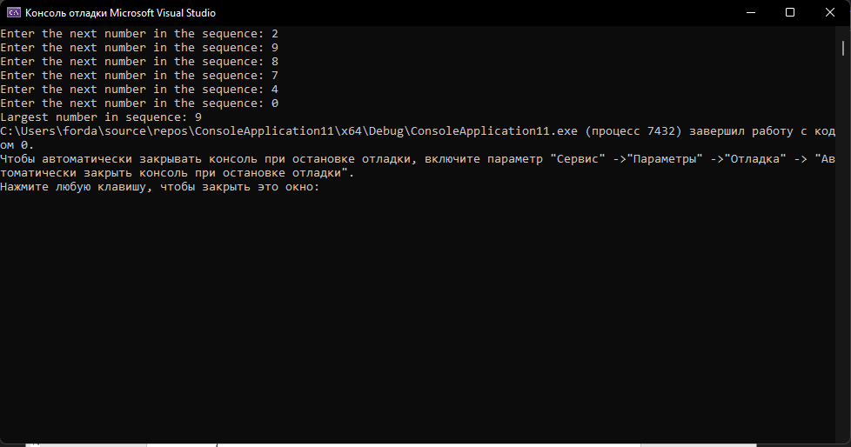

#include <iostream>

20

#include <math.h>

using namespace std;

int main()

{

int num = 1;

int sum = 0;

int sim = INT_MAX;

int raz = 0;

while (true)

{

cout << ("Enter the next number in the sequence: ");

cin >> num;

if (num == 0)

{

break;

}

if (num > sum)

{

sum = num;

}

if (num < sim)

{

sim = num;

}

}

cout << ("Smallest number in sequence ") << sim << endl;

cout << ("Largest number in sequence ") << sum << endl;

raz = abs(sum - sim);

cout << ("The ratio of the minimum and maximum elements to each other: ") << raz;

}

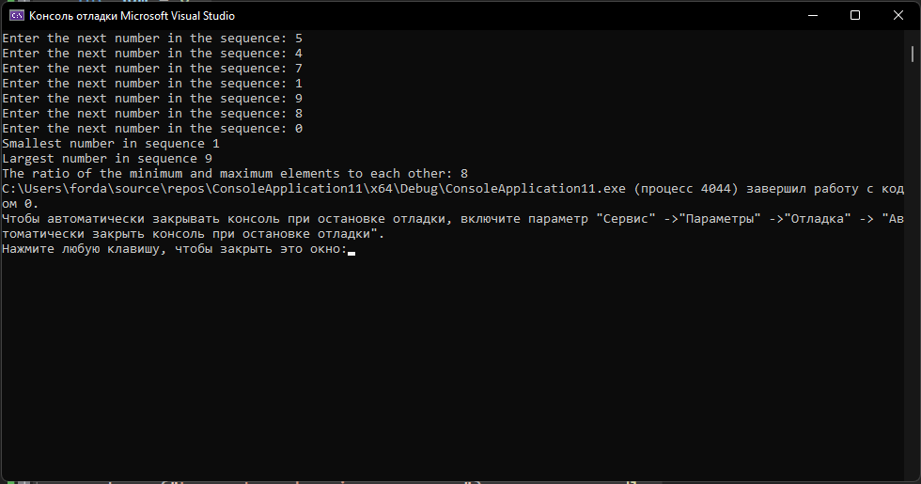

#include <iostream>

21

#include <math.h>

using namespace std;

int main()

{

int num = 1;

int num1 = 0;

int sum = 1;

int N;

cout << "Enter N = ";

cin >> N;

int temp = 0;

while (temp < N)

{

cout << "Enter next number: ";

cin >> num;

if (num == num1)

{

sum++;

}

num1 = num;

temp++;

}

cout << "The number of identical adjacent numbers: " << sum;

}

